Pymaceuticals Conclusions

Julie Nguyen

09/02/2018

Objective:

To determine the efficacy of selected drugs in Pymaceuticals’ portfolio on metastatic tumors.

Methods:

After engrafting tumors in modified mice, 250 mice were chosen based on the success of the engraftment, and 248 were included in the analysis. The mice were randomized into 10 groups, with one group receiving placebo. The trial period was 45 days, with scans every five days to measure tumor growth.

Existing tumor data for mice who did not survive to the end of the 45-day trial was included in graphical analysis up to the last scan date, and values were not carried forward to later time periods.

Findings:

Effect on Mortality:

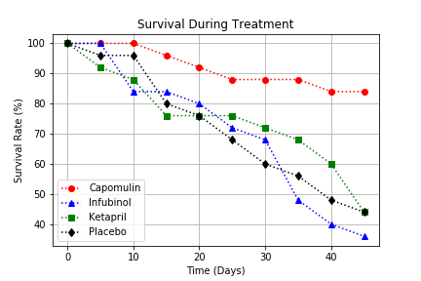

In the group of mice receiving Capomulin, 21 of 25 mice survived (84%) vs 11 of 25 mice receiving placebo (45.8%).

Effect on tumor size:

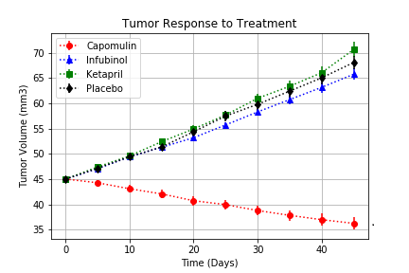

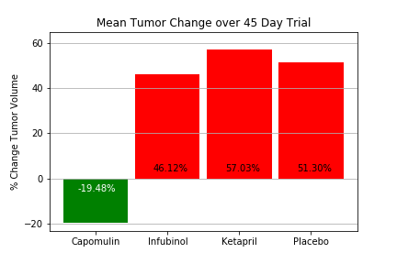

Mice treated with Capomulin experienced a reduction in tumor size over the trial period, with tumor volume decreasing an average of 19.48% by end of the trial.

Effect on Metastasis:

The average number of metastatic sites on mice receiving Capomulin was 1.5, vs 3.3 metastatic sites for mice receiving the placebo.

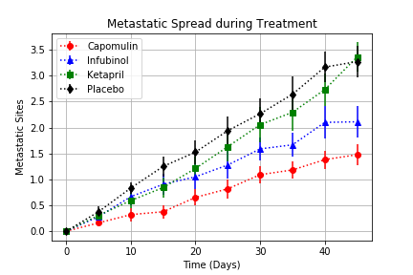

Conclusions:

Capomulin decreases mortality in mice with tumors, slows spread of tumor metastasis, and reduces tumor size.